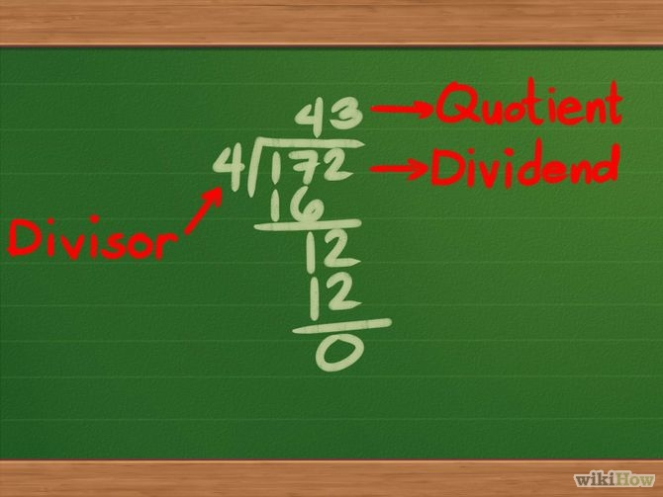**Release : post 16 monitor**

The monitor moves on apace.

Firstly the quiz question.

Well, the problem was I had SIO working backwards. Instead of reading into bit 0, shifting the others left, and outputting bit 7, it works the other way round – bit 7 is the input bit, bit 0 goes to the SOUT latch and the data is shifted right.

So LDI 0x80 ; XAE ; SIO which is supposed to set the SOUT Flag (this is the start bit) wouldn’t do anything.

Anyway, that is fixed and I have written the bulk of the arithmetic routines – addition and subtraction (easy) , multiplication (bit harder) and division (messy).

The missing bits ; division is unsigned at the moment and doesn’t test for division by zero.

I’ve got about 364 bytes left, plus some set-up-to-test code so its probably about 400 bytes or so, so looks like most of the goodies are going to fit. I might look at other mathematical operations.

We shall see.